# Experiment 8: K-means Algorithm

## Aim

To implement K-means clustering algorithm.

## Procedure

1. Initialize k centroids.  
2. Assign points to the nearest centroid.  
3. Update centroids based on mean of points.  
4. Repeat until convergence.

## Code

from sklearn.cluster import KMeans  
import numpy as np  
  
X = np.array([[1,2],[1,4],[1,0],  
 [10,2],[10,4],[10,0]])  
kmeans = KMeans(n_clusters=2)  
kmeans.fit(X)  
print("Centroids:", kmeans.cluster_centers_)  
print("Labels:", kmeans.labels_)

## Output

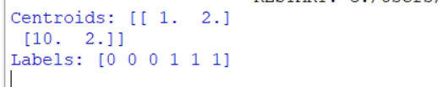

### **RESULT**

K- means Clustering algorithm is implemented